



|  |
| --- |
| 30 Follow-Up  Email Templates |



You can edit your own version in one of two ways:

1. Edit this version to fit your needs
2. Go to “File” > “Download As” > “Microsoft Word” to Download

**How to Use This Template**

Thanks for downloading HubSpot’s Follow-Up Email Templates! Included in this document are 30 customizable email templates. You can use them to follow up with anyone for sales, networking, recruiting, or any other situation.

We’ve broken down each of these templates by section for easy discovery.

Once you decide on the template you want to use, simply copy it into your email window and make it your own. You should add, delete, or edit any of the contents in the email as you see fit. We’ve also included [*Prompted Language*] for you to add in your own information.

We’ve also included some example templates for you to see how these templates might look once they go out, as well as some pro tips from The HubSpot Team for resources and best practices whenever following up.

|  |  |  |  |
| --- | --- | --- | --- |
| **Get Started with HubSpot’s Free Email Tools.**  HubSpot has free email marketing, sales, and hosting software for you and your company. | |  | |
|  | [**Get Free Email Software**](https://www.hubspot.com/products/marketing/email-hosting?utm_source=offers&utm_campaign=ql-update_follow-up-email-templates) | |  |
|  | | | |

*Keep scrolling to templates*

↓↓↓

|  |  |  |
| --- | --- | --- |
| Table of Contents | General Follow-Up Email Templates | 5 |
| Networking Follow-Up Templates | 8 |
| Sales Follow-Up Templates | 15 |
| Recruiting Follow-Up Templates | 21 |
| Bonus! Friendly Reminder Templates | 33 |
|  |  |
|  |  |
|  |  |
|  |  |

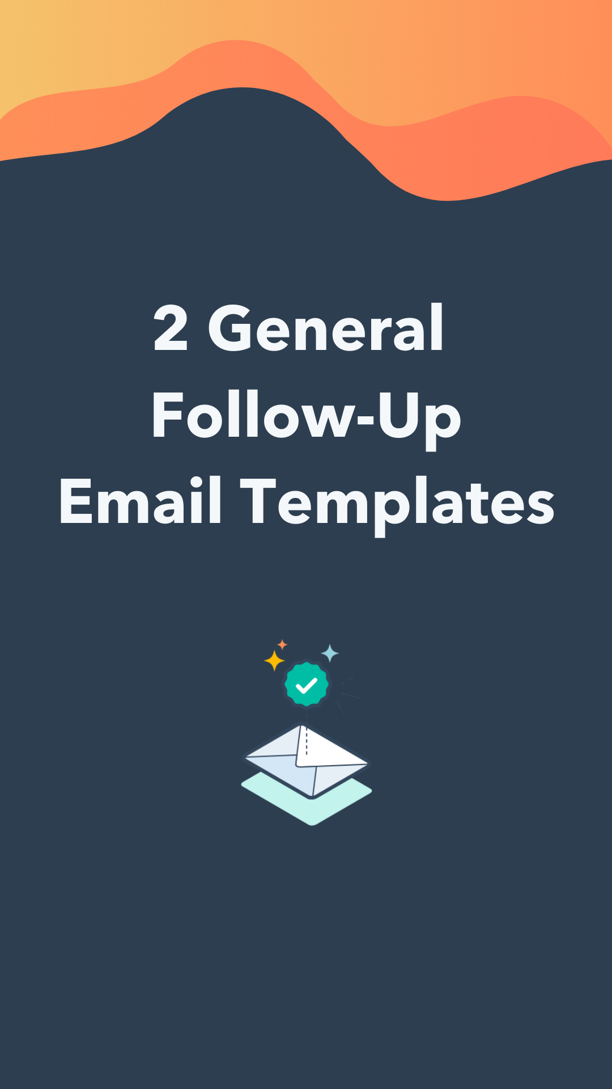

|  |
| --- |
| General Follow-Up #1 |

Hi *[First Name],*

Hope you’re having a good day!

I wanted to quickly follow up on [*Topic in Question*]. Last we spoke, I believe [*Describe Follow-Up Actions*].

With that said, would you be able to [*Outline Requested Follow-Up Actions*]?

Let me know if you have any questions for me here.

Thank you,

Signature

|  |
| --- |
| General Follow-Up #2 |

Hi *[First Name],*

Sorry for the delay on my end! To follow up on what we were talking about on [*Date of Conversation*], I wanted to send over [*Describe Deliverable*].

[*Provide an Elaboration on the Deliverable or Decision Outlined Above.*]

As for next steps, I was thinking that I would [*Outline Next Steps*] and you could [*Outline Next Steps*]. How does that sound to you?

Thanks again and let me know if you have any questions.

Signature

|  |
| --- |
| Example |

|  |
| --- |
| ⬤ ⬤ ⬤ |
| **To: Your Recipient**  **From: You**  **Subject: Follow-Up on My Timeline Request** |
| Hi Janelle*,*  Hope you’re having a good day!  I wanted to quickly follow up on the timeline for this quarter’s projections. Last we spoke, I believe you said you’d have the action plan for the next few months by the end of the week.  With that said, would you be able to send that over so I can share with my team?  Let me know if you have any questions for me here.  Thank you,  Kaysar |

|  |  |
| --- | --- |
| **Pro Tip:** | **Email Subject Lines**  When you need to send or request follow-up items over email, make sure the subject line is direct and to-the-point. Otherwise, it might get lost in the recipient’s inbox. |

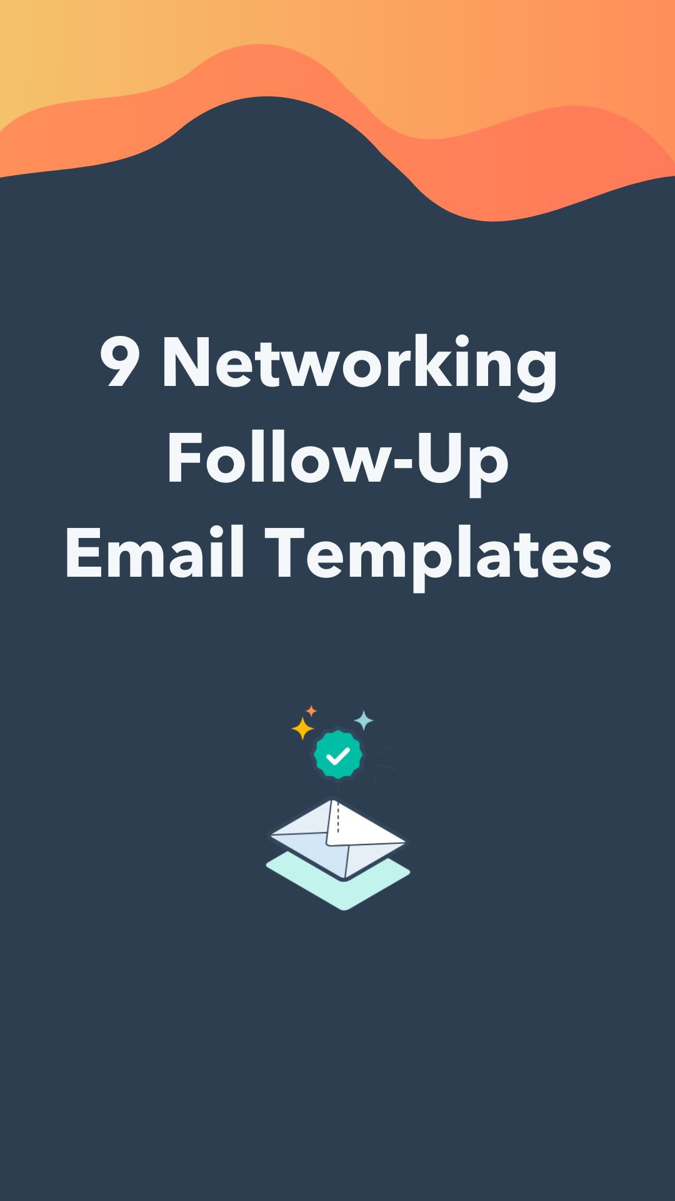

|  |
| --- |
| Making a Recommendation |

Hi *[First Name],*

So glad we got to meet at *[Event]*. I checked out your website afterward and loved your take on *[Topic]*. Have you tried using *[Recommendation you spoke about]*? I use that framework with my team and it has been incredibly successful.

Happy to chat more about it or send over some templates and examples if you’re interested.

Again, it was great meeting you at *[Event]*, and I hope to see you again soon.

Signature

|  |
| --- |
| Sharing a Resource |

Hi *[First Name],*

It was great meeting you at *[Event]*. I remember you mentioning that you’re trying to revamp *[Project/Initiative]* next quarter, and I thought I would share *[Resource]* that I used to exceed my own target goals by result.

It’s called *[Name of Resource]* and I just sent you the *[Method of Delivery. I.e. “the copy” or “the link.”]*. Hope you like it!

Happy to discuss the book or my approach if you’d like.

Just let me know!

Signature

|  |
| --- |
| General Networking |

Hi *[First Name],*

I’ve really enjoyed learning more about what you do and would love the opportunity to connect over coffee to learn more about your experience with industry or specialty. I’m currently working *[Role or Project at Company Name]* and I am very interested in learning more about how you use *[Solution/Topic Discussed]*.

I know you must be very busy, but I thought I’d try my luck. Would you be able to grab a coffee for 20 minutes on *[Day]* at *[Time]*?

Thanks,

Signature

|  |
| --- |
| Local Networking |

Hi *[First Name],*

While I’m here in *[City or Area]*, I’d love to continue the conversation we had *[Time of Last Conversation]*!

I know you must be busy, but I’ve enjoyed our talks and would love to meet up once more. If you’re around, I’m flexible to work with your schedule while I'm in town.

What days and times might work for you this week?

Signature

|  |
| --- |
| Example |

|  |
| --- |
| ⬤ ⬤ ⬤ |
| **To: Your Recipient**  **From: You**  **Subject: Coffee while I’m in town?** |
| Hi Jessica*,*  While I’m here in LA, I’d love to continue the conversation we had at the conference last weekend!  I know you must be busy, but I’ve enjoyed our talks and would love to meet up once more. If you’re around, I’m flexible to work with your schedule while I'm in town.  What days and times might work for you this week?  Eric |

|  |  |
| --- | --- |
| **Pro Tip:** | **Networking Asks**  Remember, you’re never entitled to someone’s time when networking. According to [Indeed](https://www.indeed.com/career-advice/career-development/meet-for-a-coffee), some best practices when asking for someone’s time include being straightforward and not taking a rejection personally. |

|  |
| --- |
| Clarification for a Solution |

Hi *[First Name],*

Great meeting you yesterday and learning more about your story with *[Company Name]*. I really admire how you *[Compliment towards person or company]*.

I’ve been thinking about our ongoing struggle with *[Business Challenge]*, and I was hoping you could help us solve our problem. You seem to have a great grasp on *[Business Challenge]* and I’d love to know if you’d be willing to share your insights.

Would you be able to hop on a call sometime this week to discuss more? If you’re pressed for time, perhaps you could provide a couple recommendations on how to get started here over email.

Cheers,

Signature

|  |
| --- |
| Feedback on a Project |

Hi *[First Name],*

It was great meeting you at *[Event]*!

If you recall, I was telling you about the project I’ve been working on, *[Describe project]*.

If you still had the time, I’d love any and all feedback on it. Here’s a link to what we’ve done so far: *[Insert link or attachment]*.

Specifically, I’d appreciate your insights on these questions:

1. *Question 1*
2. *Question 2*
3. *Question 3*

Thanks in advance for sharing your expertise here!

Signature

|  |
| --- |
| Thanks for Meeting |

Hi *[First Name]*,

Thank you so much for taking time out of your busy schedule to meet with me today and discuss *[Topic]*.

I enjoyed learning more about *[Specific Discussion Point]* and hearing about your experience as a *[Job Title]*.

Our discussion confirmed my interest in this industry, and I hope to keep in touch as I begin my journey towards a career path similar to the one you've taken.

Thank you again for your time and advice.

Best,

Signature

|  |
| --- |
| Making an Intro |

Hi *[First Name]*,

Thank you so much for meeting with me today. I really enjoyed our conversation and learning more about what you do at *[Company]*. I truly appreciated all your advice and tips on how to *[Topic of Discussion].*

I think you would benefit from an introduction to *[Name]*, who handles *[Task]* at *[Company]*, because *[Reason]*. I think you two would have a lot to talk about!

Can I connect the two of you over email?

Thanks again for your time the other day!

Best,

Signature

|  |
| --- |
| Asking for an Intro |

Hi *[First Name]*,

It was fantastic meeting you last week at *[Event]*. I enjoyed our conversation about *[Topic]*!

As we were discussing my projects, you mentioned that you know *[Contact Name]* over at *[Company Name]* and how she's an expert in this space. If you're willing, an introduction to *[Contact Name]* would be greatly appreciated!

Would you be able to take a moment to introduce me?

Thanks so much!

Signature

|  |
| --- |
| Example |

| ⬤ ⬤ ⬤ |
| --- |
| **To: Your Recipient**  **From: You**  **Subject: Coffee while I’m in town?** |
| Hi Jackson,  It was fantastic meeting you last week at the game. I enjoyed our conversation about strategic planning!  As we were discussing my projects, you mentioned that you knowCliff over at Petroleum Oil and how he's an expert in this space. If you're willing, an introduction to Cliff would be greatly appreciated!  Would you be able to take a moment to introduce me?  Thanks so much!  Holly |

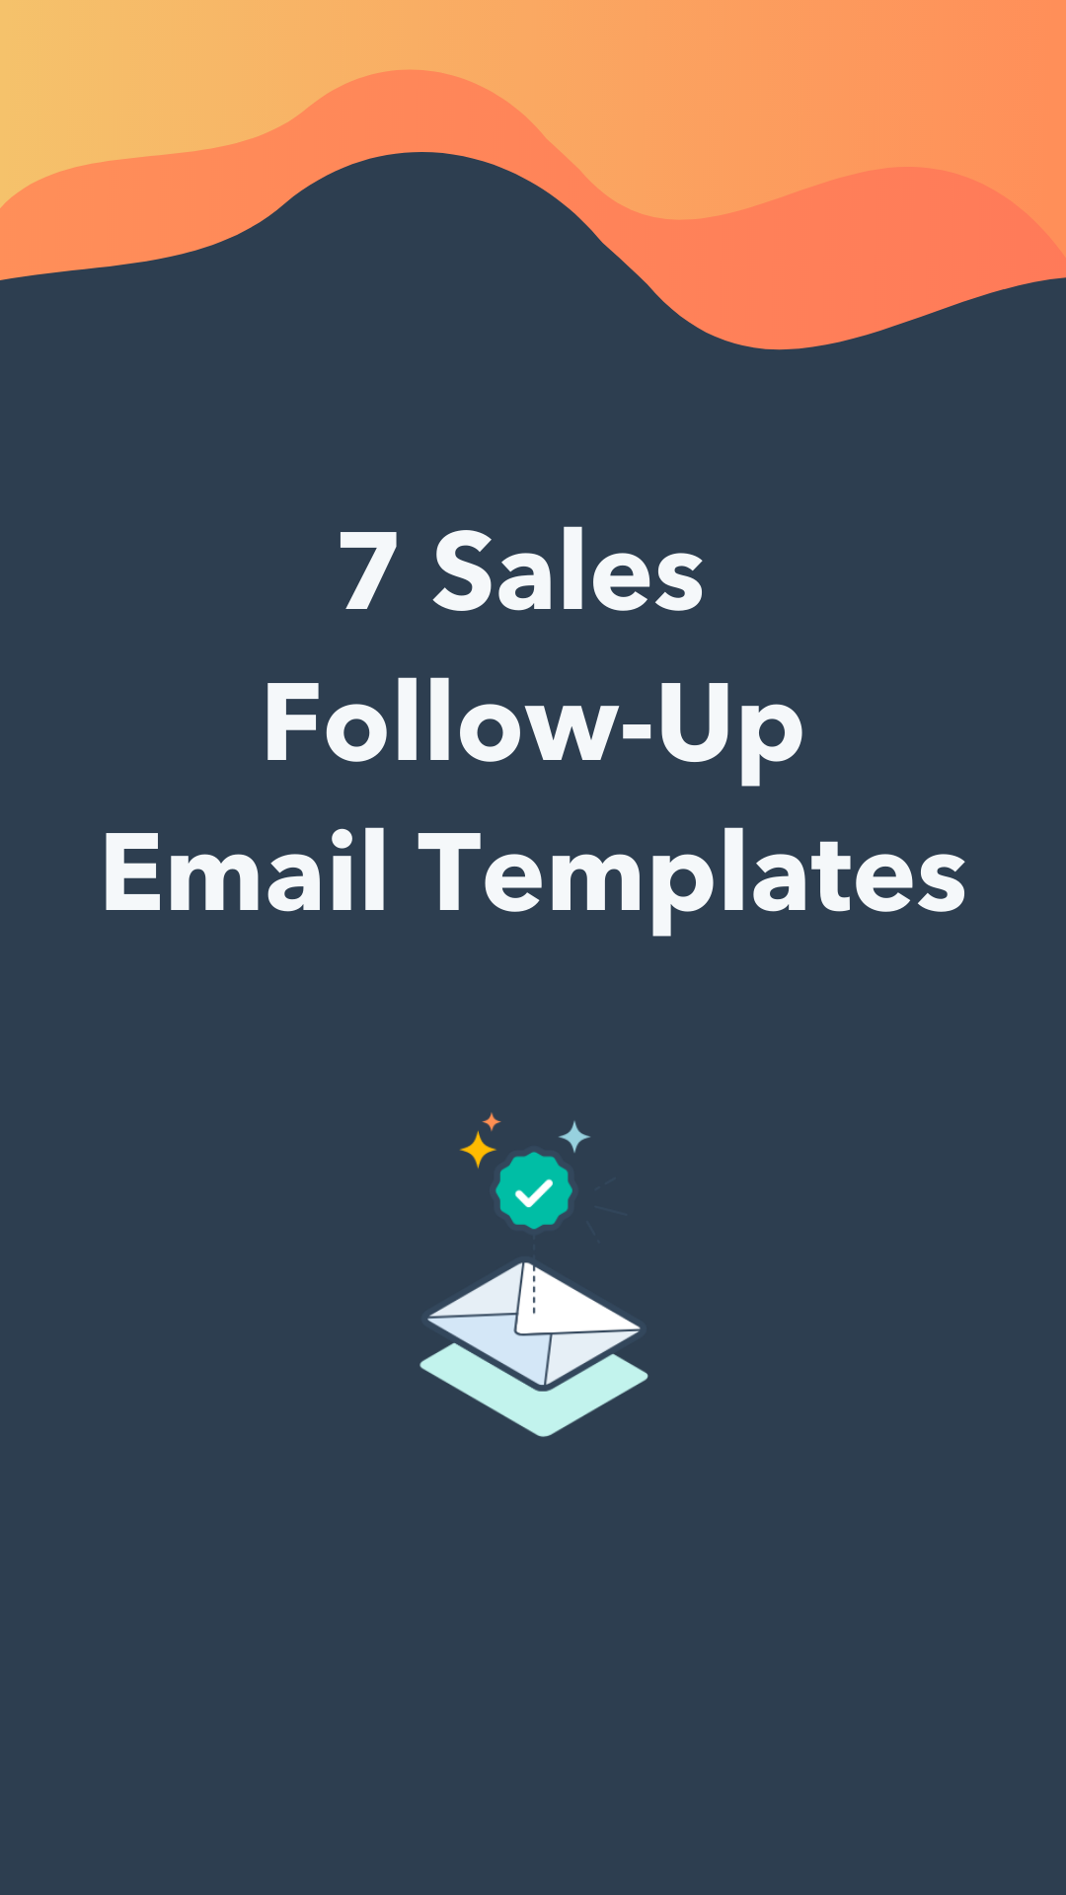

|  |
| --- |
| Resending Resources |

Hi [*First Name*],

Hope you’re well. Did you have a chance to look at the [*Resource Type(s)*] I sent last week?

Since it was a pretty long list, I’ve compiled the most useful ones below:

* [*Asset #1*]: This is a great how-to on resolving [*Business Pain Point*] – very quick read.
* [*Asset #2*]: You were curious about [*Insert Product Feature*], and this is a great summary written by my colleagues.
* [*Asset #3*]: Here’s a case study about [*Company Name*], a company in your industry that has benefited from our services.

I’d love to touch base this week and see if we can help [*Business Name*] [*Explain Desired Results*]. Are you free on [*Date*] for a ten-minute call?

Thanks,

Signature

|  |
| --- |
| Follow-up After a Demo |

Hello [*First Name*],

Just bumping this up in your inbox. Did you get a chance to speak to [*Decision Maker Name*] about moving forward with [*Product/Service Name*]?

If not, I’d love to set up a phone call so I can get you started [*Desired Results*]. Are you and your manager available on [*Day*] morning for a brief phone call?

Thanks

Signature

|  |
| --- |
| Follow-up After a Missed Call |

Hey [*First Name*],

It seems like it’s not a great time for us to connect, but I really think [*Product Features*] could help your business [*Explain Desired Results*].

If you’re not the right person to talk to, whom should I reach out to?

Thanks,

Signature

|  |
| --- |
| Follow-up After Connecting on Social Media |

Hey [*First Name*],

It was great to connect with you on [*Social Media Platform*] last week. I’m touching base again with a few resources that I think would be helpful as your business tries to [*Outline Desired Results*].

* [*Link 1*]: [*Explain Value of Asset*]
* [*Link 2*]: [*Explain Value of Asset*]
* [*Link 3*]: [*Explain Value of Asset*]

If this isn’t a good time for us to connect, I’d love for us to stay in contact. Submit this form [*Insert Link*] so you can be the first to learn about our product updates straight from me.

I’ll be looking out for your submission.

Thanks!

Signatur

|  |
| --- |
| Example |

|  |
| --- |
| ⬤ ⬤ ⬤ |
| **To: Your Recipient**  **From: You**  **Subject: Thanks for Connecting on LinkedIn!** |
| Hey Jun,  It was great to connect with you on LinkedIn last week. I’m touching base again with a few resources that I think would be helpful as your business tries to grow its marketing program.   * [Marketing Plan Template](https://offers.hubspot.com/marketing-plan-template): Use this to outline your marketing strategy this year. * [Digital Marketing Ebook](https://offers.hubspot.com/beginners-guide-to-digital-marketing): An introductory guide for small businesses. * [Advertising Planning Kit](https://blog.hubspot.com/marketing/best-advertisements): Templates and a guide for smarter advertising.   If this isn’t a good time for us to connect, I’d love for us to stay in contact. Submit this form so you can be the first to learn about our marketing and product updates straight from me.  I’ll be looking out for your submission.  Thanks!  Alison |

|  |  |
| --- | --- |
| **Pro Tip:** | **Sharing Resources**  The inbound methodology requires companies to earn the trust of their prospects with helpful resources and education. Keep this best practice in mind as you communicate follow-ups to prospects. |

|  |
| --- |
| Follow-up After Sending a Quote |

Hi [*First Name*],

Hope your week is going well. Did you get a chance to look over the quote I sent on [*Date*]?

The sooner I get the quote approved, the sooner we can get your business to [*Explain Desired Results*].

I’d be happy to answer any questions and discuss the terms of the contract. Let me know if you’d like to hope on a call on [*Date*].

Thanks,

Signature

|  |
| --- |
| Following Up After Sending Product Samples |

Hi [*First Name*],

Hope you’re enjoying the product samples so far. I sent you an email last week to get your thoughts on the samples and wanted to check back in.

How are the [*Product Type*] samples working for you? I’ve compiled a comparison chart for the products I sent over:

[*Insert Comparison Chart*]

Once again, I would recommend [*Product*] because of its [*Key Feature*], which we think would be the best fit for you.

Are you curious about any additional products? Can I send you any more samples?

Thanks,

Signature

|  |
| --- |
| Following Up After a Free Trial |

Hey [*First Name*],

Just reaching out to let you know that your free trial will end on [*Date*].

How are you enjoying [*Product/Service Name*]? Has it helped your business [*Outline Desired Results*]?

If you need more time before making a choice, that’s totally understandable. Email me back if you’d like a trial extension, and I’ll work with our product team to get you one more week.

In the meantime, I’d love to hear how the product has been working for you. Are you available on Wednesday afternoon for a 15-minute call?

Thanks,

Signature

|  |
| --- |
| Example |

|  |
| --- |
| ⬤ ⬤ ⬤ |
| **To: Your Recipient**  **From: You**  **Subject: Your free trial ends next week** |
| Hey Tiffany,  Just reaching out to let you know that your free trial will end on **June 1st**.  How are you enjoying your cookout martials? Have they helped increase your catering company’s productivity?  If you need more time before making a choice, that’s totally understandable. Email me back if you’d like a trial extension, and I’ll work with our team to get you one more week.  In the meantime, I’d love to hear how the product has been working for you. Are you available on Wednesday afternoon for a 15-minute call?  Thanks,  Xavier |

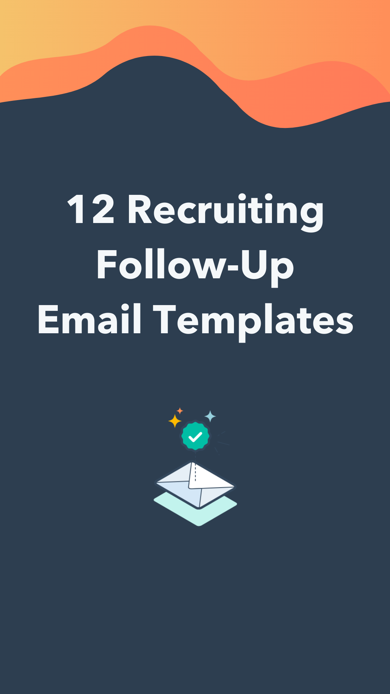

|  |
| --- |
| Follow-Up Email After Meeting a Recruiter |

Hi [*First Name*],

My name is [*Your Name*]. I am a [*Current Position*] and we met today at [*Recruiting Event*].

I just wanted to thank you again for sharing your experience at [*Company Name*] with me and for providing me with information about the [*Job Title*].

Hearing about your organization’s success with [*Initiative*] and learning more about the [*Culture Description*] culture made me very excited to further explore opportunities with the team at [*Company Name*]. I really appreciate your time and advice.

I've attached my resume for reference and a few of the projects I mentioned to you as well. Please let me know if there’s anything else you need on my end. I look forward to talking again soon!

Best,

Signature

|  |
| --- |
| Follow-Up Email After Social Media Outreach |

Hi [*First Name*],

My name is [*Your Name*] and I reached out to you earlier today on [*Social Platform*]. I found the job listing for [*Company Name*] and wanted to get in touch with you about it.

I believe I would be a welcomed addition to your team for the following reasons:

1. [*Compelling Reason #1*]
2. [*Compelling Reason #2*]
3. [*Compelling Reason #3*]

Attached is my resume and cover letter explaining why I would be a great employee at your organization. I've also included relevant work sample(s) for your review.

Looking forward to hearing from you, [*First Name*]!

Thank You,

Signature

|  |
| --- |
| Follow-Up Email After Application |

Hi [*First Name*],

It looks like things are going well for you all over at [*Company Name*] right now!

I recently saw the position of [*Role You Applied For*] posted. After looking it over, I knew I would be a great fit. I applied yesterday and wanted to let you know how excited I am to learn more about your company and the team through the application process.

Do you know what the [*Relevant Department*] department’s hiring situation may look like for this role? I’m eager to meet you all and share my experiences. I’ve reattached my resume and cover letter again here for reference.

In the meantime, please let me know if you have any questions for me.

Thanks,

Signature

|  |
| --- |
| Follow-Up Email After Phone Interview |

Hi [*First Name*],

Thank you again for talking with me today. I appreciated learning more about your work as [*Job Title*] and your experience at [*Company Name*]. I especially loved hearing about your work on [*Project/Initiative*], which I truly thought was fascinating.

I know you’re considering several candidates for this role, so I wanted to share some relevant work with you during your hiring process. Here’s a project I worked on at [*Company Name*], where I [*Describe Project and Outcome*]: [*Insert Link to Project*]

Finally, here is a link to my website where you can see more of my publications and projects: [*Link to Website*].

Let me know if you have any questions about anything or if you'd like me to send something else. I look forward to hearing back from you!

Signature

|  |
| --- |
| Example |

|  |
| --- |
| ⬤ ⬤ ⬤ |
| **To: Your Recipient**  **From: You**  **Subject: My Application for Sales Rep** |
| Hi Drew,  It looks like things are going well for you all over at Armicare right now!  I recently saw the position of Junior Sales Rep posted. After looking it over, I knew I would be a great fit. I applied yesterday and wanted to let you know how excited I am to learn more about your company and the team through the application process.  Do you know what the Sales department’s hiring situation may look like for this role? I’m eager to meet you all and share my experiences. I’ve reattached my resume and cover letter again here for reference.  In the meantime, please let me know if you have any questions for me.  Thanks,  Diane |

|  |  |
| --- | --- |
| **Pro Tip:** | **Speaking with Recruiters**  Remember to follow up with recruiters with empathy. Recruiters are likely juggling hiring for multiple roles. If you’re direct but polite, you’re more likely to receive a positive response that reflects well on your application. |

|  |
| --- |
| Follow-Up Email After Interview |

Hi [*First Name*],

Thank you so much for taking the time to talk yesterday!

It was a pleasure to learn even more about [*Company Name*] and how you approach [*Industry*] with an innovative strategy. I’m very excited about the opportunity to explore a potential career with the [*Department Name*] department.

Again, I appreciate the opportunity to have shared my background and interest in the [*Position Name*] position with you. I think my experience with [*Skill, Type of Work, or Product*] aligns perfectly with what your team is looking for, and I hope to prove that.

I’ve also attached a copy of the project I was talking to you about in the interview.

Thank you, and I hope we’ll be in touch soon!

Best,

Signature

|  |
| --- |
| Follow-Up Email After Second Interview |

Hi [*First Name*],

Thank you for the opportunity to come and chat a second time. I didn’t think I could be any more enthusiastic about working with your team after the first interview, but I was wrong.

The whole package sounds incredible, from detail about position that excited you to the endless opportunities for growth.

In fact, after we discussed [*Initiative Name*], I had a quick idea about making it successful. Attached is a quick explanation of what I was thinking. Whether this is on-point or completely off-base, I hope to get the chance to discuss it.

Let me know if there’s anything else you need from me. I look forward to hearing from you!

Thanks again,

Signature

|  |
| --- |
| Follow-Up Email After No Response |

Hi [*First Name*],

I hope you’re doing well!

I wanted to follow up, as it has been [*Duration*] since we last spoke about [*Job Title*]. At the time, you mentioned you were making decisions on next steps by [*Time Frame*], and I was wondering if that was still the case.

I’m still very interested in working with your team at [*Company Name*]. Do you have a timeline for when I might hear back regarding the next stages of the process?.

I understand if the position has already been filled or if you’ve decided to move forward with other candidates, but I wanted to reiterate my enthusiasm about working with such an incredible group of people at [*Company Name*].

Thank You!

Signature

|  |  |
| --- | --- |
| **Pro Tip:** | **Soliciting a Follow-Up Response**  It’s understandable if you’re anxiously awaiting an update, but keep in mind there is a behind-the-scenes process you may not be keen to.  Simply use this email template to politely send a nudge to your recruiter. When done well, it can reinforce your interest in the role. |

|  |
| --- |
| Follow-Up Email to Ask For More Time On An Offer |

Hi [*First Name*],

Thank you so much for your time yesterday and for the offer to work for [*Company Name*]!

I'm very excited about the position. It’s exactly what I’ve been looking for and I’m thrilled I’ve been extended the opportunity to work for [*Company Name*]’s [*Team Name*] Team.

I hate to delay my response to your offer, but I still need some time to respond to other offers. I want to reiterate, though, that I am honored to be qualified for the position, and I appreciate the opportunity to learn from such an inspiring group of individuals. I just feel it would be imprudent of me to commit before considering all of my options.

With that said, I do recognize that you have time constraints as well, so I completely understand if you need a more immediate response. Can I touch base with you early next week?

Thank you again for your time and the consideration you put into reviewing my qualifications.

Again, I am honored to have been extended this opportunity!

Thank you,

Signature

|  |
| --- |
| Follow-Up Email to Recruiter After Accepting An Offer |

Hi [*First Name*],

Thank you for your time and for the generous offer!

At this time, I’m thrilled to say I would love to accept the offer as [*Job Title*] for [*Company Name*].

Again, I'm honored to have received the offer.

Please let me know about the next steps. I'll be awaiting my start date in anticipation in the meantime. I look forward to working with you and the rest of the team!

Signature

|  |
| --- |
| Follow-Up Email After Declining An Offer |

Hi [*First Name*],

Once again, an enormous thank you to you and the team for the time you put into the interview and for entrusting me with this offer. I was ecstatic when I heard back from you with an offer to be [*Company Name*]’s new [*Job Title*]. It's an incredible opportunity and I'm honored to have been extended an offer. However, I have decided to pursue another opportunity at this time.

This was honestly a tough decision for me because I've had such a great experience talking with you and everyone else on the team. One of the main reasons I chose to accept the other offer is [*Explain Reason*].

I truly appreciate your team’s time and I enjoyed learning more about the culture over at [*Company Name*]. I would still love to keep in touch and I hope you and the team understand my decision.

Thank you again for your time and consideration. I wish you all the best, and I hope to talk again soon!

Take care,

Signature

|  |
| --- |
| Example |

|  |
| --- |
| ⬤ ⬤ ⬤ |
| **To: Your Recipient**  **From: You**  **Subject: My Application for Sales Rep** |
| Hi Paul,  Once again, an enormous thank you to you and the team for the time you put into the interview and for entrusting me with this offer. I was ecstatic when I heard back from you with an offer to be HairCare’s new Product Designer. It's an incredible opportunity and I'm honored to have been extended an offer. However, I have decided to pursue another opportunity at this time.  This was honestly a tough decision for me, because I've had such a great experience talking with you and everyone else on the team. One of the main reasons I chose to accept the other offer is that my new employer was able to offer me a role more in line with my interest in graphic design.  I truly appreciate your team’s time and I enjoyed learning more about the culture over at HairCare. I would still love to keep in touch and I hope you and the team understand my decision.  Thank you again for your time and consideration. I wish you all the best, and I hope to talk again soon!  Take care,  Josh |

|  |  |
| --- | --- |
| **Pro Tip:** | **Rejecting an Offer**  Don’t burn any bridges! Rejecting an offer with gratitude for the gesture is the best way to end the process. You never know what opportunities await you if you handle this rejection well. |

|  |
| --- |
| Follow-Up Email to Hiring Manager After Accepting An Offer |

Hi [*First Name*],

I hope you’re doing well!

I just wanted to share that I just confirmed with [*Recruiter Name*] that I will be accepting the role of [*Job Title*]. I’m humbled you and the team entrusted me with this position and I look forward to working with all of you very soon.

In the meantime, let me know if you have any questions for me before my start date. I can’t wait to get started!

All the Best,

Signature

|  |
| --- |
| Follow-Up Email to After Being Rejected |

Hi [*First Name*],

Thank you so much for getting back to me. I know this was a tough decision for your team and I respect the time and thought that went into making it. While I’m disappointed, I’d love to keep the door open for future opportunities if you continue to think I could be a good fit at [*Company Name*].

If at all possible, would you mind providing feedback on what I can improve upon in the future? I’d love to know where my opportunities for bettering my presentation and interview skills lie and would appreciate any pointers you and the team might be able to provide me.

If you do find yourself recruiting for a role that I may be a good fit for, please don’t hesitate to reach out. I’d be honored to be considered for another role at [*Company Name*].

Thank you again!

Signature

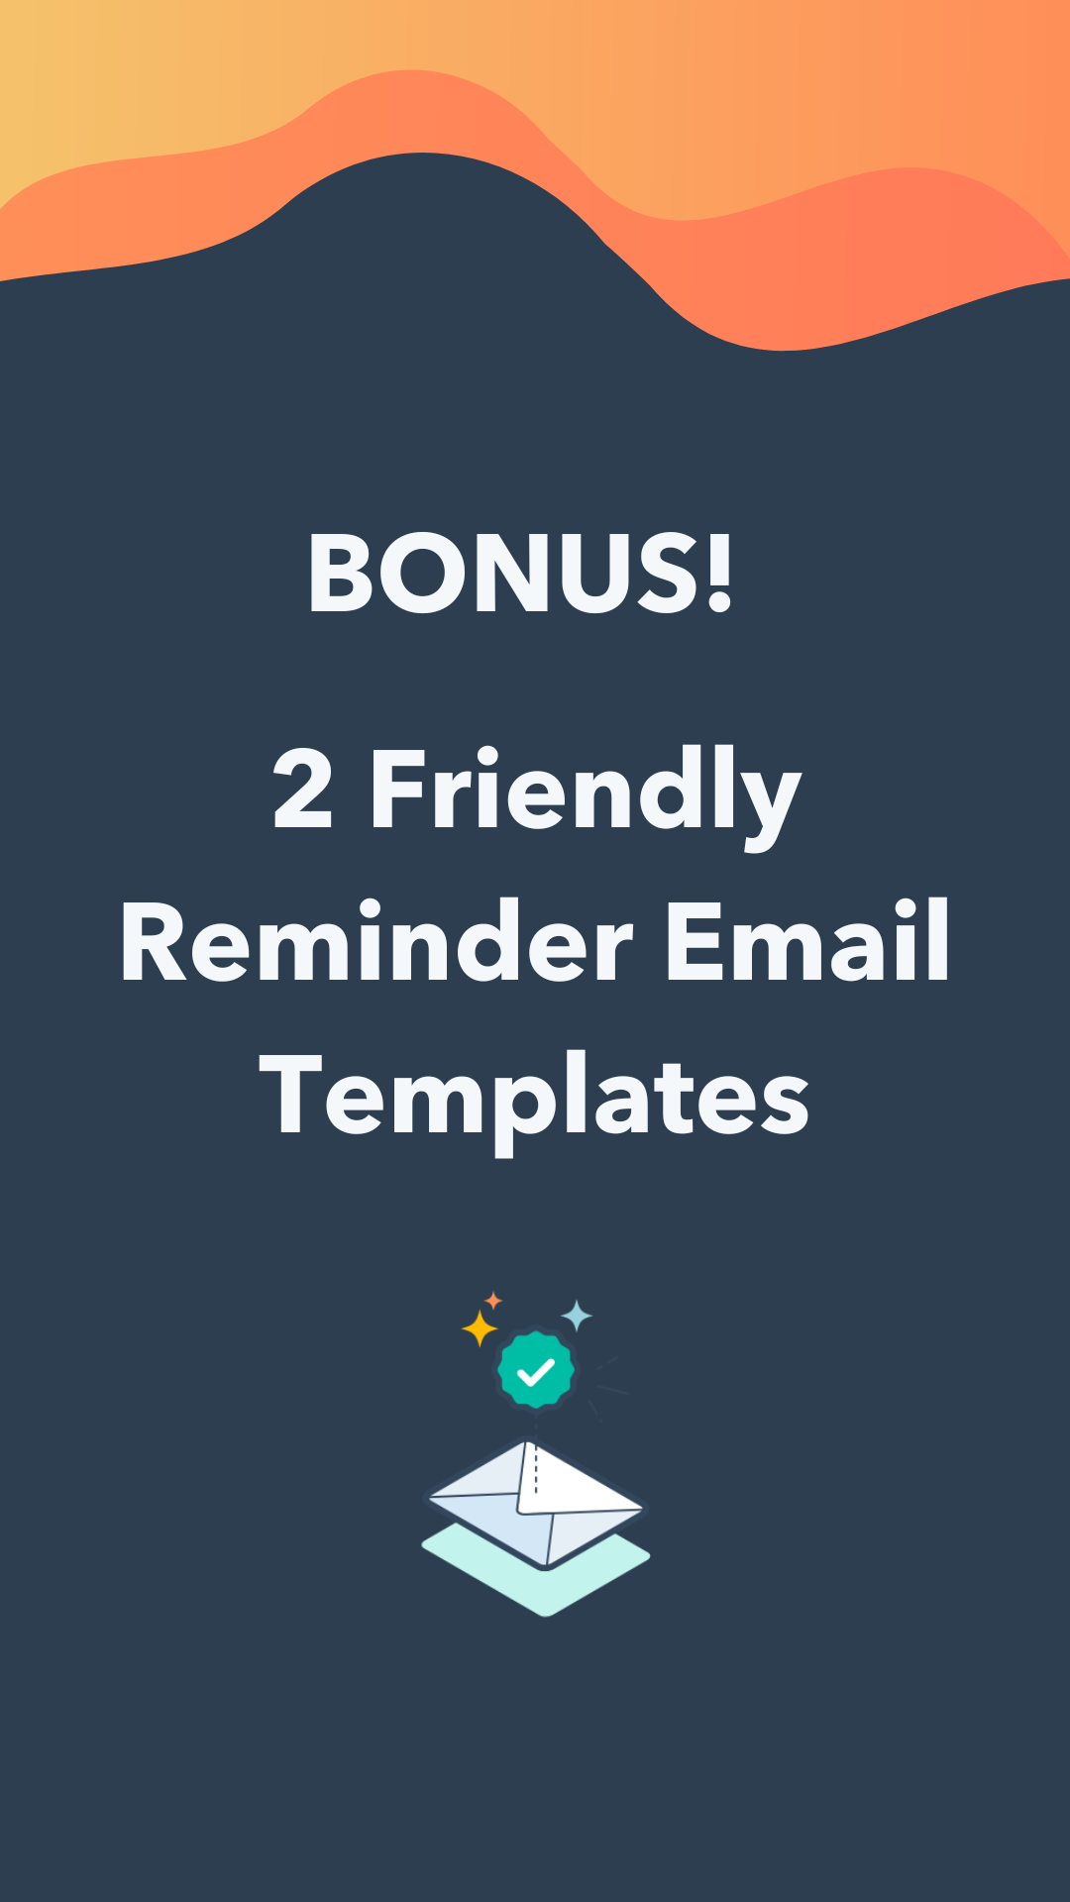

|  |
| --- |
| Friendly Reminder for a Due Date |

Hi [*First Name*],

Hope your week is going well!

I wanted to send a friendly reminder that [*Deliverable*] is/was due on/by [*Due Date*]. Without [*Deliverable*], [*Implication of Late/No Deliverable*].

Please let me know if you have anything precluding you from getting [*Deliverable*] by [*Date*]. I’m happy to help or answer any questions if needed!

I appreciate your help here and look forward to hearing from you soon!

Best,

Signature

|  |
| --- |
| Friendly Reminder for Favor |

Hi [*First Name*],

Thank you again for taking the time to speak with me on [*Day*]!

I was hoping to send a friendly reminder about my request for [*Favor*]. Your [*Description of Favor*] would go a long way as I [*Description of Activity/Goal That the Favor Would Help With*].

I truly value your time, assistance, and expertise here — so would it be possible to have [*Favor*] by [*Preferred Due Date*]? That way, I’d be able to [*Benefit of Favor Being Complete by Date*].

If this isn’t feasible, please do let me know.

Again, thank you so much for your help!

Signature

|  |
| --- |
| Example |

|  |
| --- |
| ⬤ ⬤ ⬤ |
| **To: Your Recipient**  **From: You**  **Subject: Follow-Up on My Job Reference** |
| Hi Taylor,  Thank you again for taking the time to speak with me on Tuesday!  I was hoping to send a friendly reminder about my request for a referral to the open role at your company. Your reference would go a long way as I aim to complete my application at Hale Media!  I truly value your time, assistance, and expertise here — so would it be possible to have your reference submitted by the end of the day tomorrow? That way, I’d be able to submit my application by the end of the week.  If this isn’t feasible, please do let me know.  Again, thank you so much for your help!  Monte |

|  |  |
| --- | --- |
| **Pro Tip:** | **Sending an Effective Friendly Reminder**  When asking for a favor, don’t forget to make the recipient feel important and valued. If you show how much you appreciate their input/work, they’ll be more likely to be willing to help you sooner. |