|  |
| --- |
| **Hi There.**  Thanks for Downloading This Template! |
| ↓↓↓  How to Use This Template  Thanks for downloading HubSpot’s Customer Service Strategy & Planning Template!  This tool was built for you to outline and document your company’s customer support strategy. Included are sections common in most customer support plans, as well as prompts for you to fill out your company’s tactics and information. Simply erase the italicized instructions under each header and replace them with what makes sense for your business.  Once complete, this plan can be shared with support reps and managers, the customer success team, marketing, sales, new customers, investors, or whomever you see fit.  Keep in mind, this template is designed to be completely customized by your company. If you feel there are sections included that you would rather omit, or if you think a section is missing, you are encouraged to make those changes as you see for your business. |

[****](https://hubs.ly/H0g0sq50)

[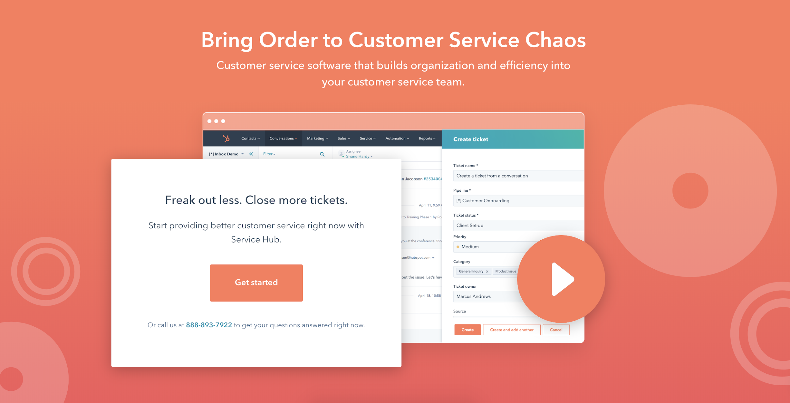](https://www.hubspot.com/products/service?utm_source=offers&utm_campaign=ql-update_support-strategy-template)

**Need help putting your support plan into action?**

HubSpot’s free CRM with integrated support software is a dream come true for companies looking to scale their support performance. This tool includes free ticketing, team emails, reporting, live chat, meeting scheduling, and more.

## [Want to learn more? Sign up for HubSpot Service Hub for free.](https://www.hubspot.com/products/service?utm_source=offers&utm_campaign=ql-update_support-strategy-template)

*[Company Logo]*

*[Company Name]*

*Customer Service Strategy Plan: [Period of Time, i.e. Q1 2019, FY 2020]*

*Written by: [Your Name]*

*[Your Email]*

**Table of Contents**

1. Company Mission and Background..…………………………………………………………##
2. Customer Service Vision………………………………………………………………....…....##
3. Team/Hiring……………………………………………………………………………………..##
4. Support Process………………………………………………………………………………...##
5. Tools, Software, and Resources………….………..………………………….…….….…..…##
6. Goals and Metrics……………….….….….…………….…………………….…………….…##
7. Budget…………………………………..……………………………….…...………………….##

**Company Mission and Background**

*In this section, give context as to why your business exists. Cover your mission statement, vision statement, and an abridged company history for readers to understand the context of the business.*

**Mission Statement**

*[Enter your company’s mission statement]*

**Vision Statement**

*[Enter your company’s vision statement]*

**Company History/Story**

*[Enter your company’s story and/or abridged history]*

**Customer Service Vision**

*In this section, highlight the vision of your team’s customer support frontline. This should be the North Star of your support reps and help readers understand what your team’s priorities are.*

**Customer Service Vision Statement**

*[Enter your company’s customer service vision statement]*

**Team & Hiring**

*Who are the leaders of your support department? How is the department structured?*

**Support Leadership**

*[Name the leaders of your support department and their titles. Optionally, you can add photos of the support leaders and/or a professional bio.]*

**Support Team Structure**

*[Explain the organization of your support department. You can structure this section by region, team, or hierarchy. If you have an org chart filled out, this would be the perfect place to put a copy or a screenshot of it.]*

**Scheduling**

*[Will you offer 24/7 support through internal support reps? What about weekends? How will the scheduling breakdown look during these off-hour times (i.e. will reps rotate out of night/weekend shifts, or will the same reps always work those times?)]*

**New Hires**

*[How will your team grow? Explain where the gaps in your head count are and what will be done before the spots are filled.]*

**Training**

*[Outline your customer support training strategy for these new hires. You may want to link out to your* [*customer support training manual*](https://offers.hubspot.com/customer-service-training-manual-template?utm_source=offers&utm_campaign=ql-update_support-strategy-template)*.]*

**Support Process**

*Here’s where you’ll discuss the way your team approaches support, handles tickets, and thinks about resolving issues.*

**Common Support Topics**

*List the main reasons customers reach out to the support team.*

**Anatomy of a Support Call**

*[Outline the steps and structure involved in a typical support call for reps to follow. For example:*

*1. Greeting*

*2. Listening to Problem*

*3. Repeating Problem Back to Confirm*

*4. Looking for Solution*

*5. Providing Solution or Redirecting to Proper Person*

*6. Concluding Call and Thanking the Customer]*

**Interacting with Customers**

*[Provide a few best practices on how to interact with those who call in or email for support needs. This is especially important for rude, angry, or impatient customers. This is the perfect place to link to your company’s support tone guide and to call out terms to (not) use.]*

**Escalation Framework**

*[Provide your company’s escalation framework for when a situation should be escalated to management or transferred to a different rep. A list or a visual aid, such as a chart, would benefit this section.]*

**Refunds, Returns, or Cancellations**

*[Explain what justifies a refund or a return in your company, if applicable, and what response should be given when a customer asks for a refund when it is not permissible. This type of interaction usually requires explicit direction to new team members.]*

**Tools, Software, and Resources**

*Explain what resources the support team uses to accomplish its goals. This includes* [*CRM software*](https://hubs.ly/H0g0sqn0)*, documentation, knowledge base, and any other tools used in support.*

Software

*[Identify the customer support management software used. If you do not have a support software yet, try* [*HubSpot’s*](https://hubs.ly/H0g0sqn0) *for free!]*

Tools and Resources

*[Identify the documentation and resources support can employ to do their jobs. This may include a knowledge base, a Slack channel, and more. In a nutshell, if there’s something in your business that can strengthen a support rep’s performance, identify it here.]*

Channel Strategy

*[How do support reps receive tickets – by phone, email, chat, social media, in person, or a combination of these? Identify the tools you’ll use to address support tickets in these channels, like a social monitoring tool or the phone system you’re using.]*

**Goals and Metrics**

*What are your goals for support? These goals are contingent on how often you plan to update your support plan, so specify what time period these goals are valid for.*

First Contact Resolution Goal

*[What is your targeted FCR goal, and why?]*

Average Ticket Time Goal

*[What is your targeted average ticket time goal, and why?]*

Customer Satisfaction Score Goal

*[What is your targeted CSAT goal, and why?]*

Goal #4

*[What is your target for Goal #4, and why?]*

Goal #5

*[What is your target for Goal #5, and why?]*

[If you need a method to calculate these customer service metrics, download this free customer service metrics calculator.](https://offers.hubspot.com/customer-service-metrics?utm_source=offers&utm_campaign=ql-update_support-strategy-template)

**Budget**

*Outline the budget for your support initiatives, including salaries, bonuses, team outings, resource and software expenses, hiring, training, travel costs, food, and more.*

**Did We Miss Something?**

*Add another section here if you need it.*

### 

### 