

Hi There.

Thanks for Downloading This Resource.


↓↓↓
How to Use This Template
Thanks for downloading HubSpot’s Advertising Plan Template!

This document is intended to help you organize your thoughts, plans, processes, and resources for your ad campaigns.

This is an editable, copiable template, so you’re encouraged to make any changes or alterations that make sense for your business and make a duplicate version whenever you run another ad campaign for your business.

When you finish completing this outline, delete this introduction section as well as all of the italicized instructions and placeholder text before sharing with your team.

There’s no time to lose – let’s get started!

Need help putting your advertising plan into action?  Align your sales team with  HubSpot’s Marketing Hub software. | 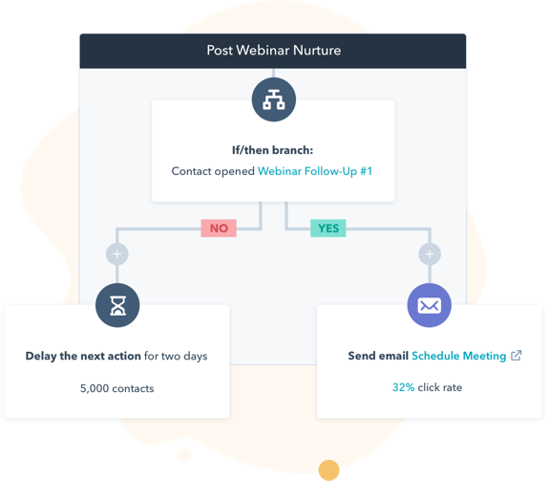
Get Started with Marketing Hub

(Keep scrolling to templates)
↓↓↓

Outline of Initiative

In this section, you should answer the high-level questions an employee at your company might have about your campaign, like who you’re targeting, why you’re running this campaign, and what medium you’ll be advertising on.

Name of Campaign: Example – Q3 Product Launch Advertising Campaign

Description of Campaign: Provide a 1-3 paragraph description of the inspiration behind your campaign, answering the following questions:

- How does this problem align with our product/service?
- Why are we solving this problem?
- What are the deliverables for this campaign?

Target Audience: Identify whom you’re targeting. This could be a description of the audience you’re targeting (i.e. “Entry-level salespeople in B2B tech companies”) or one of your buyer personas like “Owner Ollie” or “Manager Mary." Never made a buyer persona before? Use this tool to get started.

Advertising Platforms: Which platforms will you be utilizing in your advertisements? Don’t get too into timeline or budget just yet – you’ll cover that in later sections. Not sure which platform to use? Check out the ebook included in this kit for the pros, cons, budget, and ROI of the most common advertising platforms.

Goals: At the end of this campaign, what is your expected goal? Quantify your expectations clearly, such as “300 new customers” or “20% better brand recognition in next quarter’s surveys.”

Advertising Platform(s)

Where will you be advertising your message? Will the content on each platform be the same, or different? For example, your Google ads would be text-based, but your Facebook ads might be video, text, or both. If desired, you can also outline your budget, timeline, and goals for each platform.

Platform #1: YouTube

- Advertisement Type: Video
- Description of Ad: A 15-second pre-video ad. The video will be an animated look at our new app with a link to the app store at when someone clicks.
- Timeline: July 1 – July 31
- Budget: $10,000

Platform #2: Facebook
- Advertisement Type: Image
- Description of Ad: A custom-made image by our design team, featuring a photo of our app’s interface. The copywriting team will produce ad copy to support, and the ad will link to the app store.
- Timeline: July 15 – July 31
- Budget: $50,000

Platform #3: Google Ads
- Advertisement Type: Text Google Ad
- Description of Ad: The copywriting team will create the copy for a Google ad within the text limits, linking to where people can download the app. There will be three ads in one group, and after one week we will revisit to see if one of the ads is underperforming and should be reworked.
- Timeline: August 1 – August 21
- Budget: $10,000

Timeline

Use this section to outline a timeline for this project, from first steps to analysis of the campaign. Start off by reminding the overall timeline for the entire project before diving into incremental deadlines and timelines. Included is a sample timeline or potential objectives you may include in your outline, and these items should be altered to fit your campaign.

Overall Project Timeline: Start Date – End Date

Task #1: Researching and Outline
Due Date: June 1st

Task #2: Project Brief Sent Out to Stakeholders
Due Date: June 5th

Task #3: Team Meeting with Stakeholders
Due Date: June 8th

Task #4: Designs from Creative Team Due
Due Date: June 15th

Task #5: Video Due
Due Date: June 21st

Task #6: Copy from Copywriting for All Ads Due
Due Date: June 23rd

Task #7: Packaged Drafts Sent to Decision Maker
Due Date: June 24th

Task #8: Feedback on Creative Due
Due Date: June 26th

Task #9: Edits on Creative Due
Due Date: June 30th

Task #10: YouTube Ad Launches
Due Date: July 1st

Task #11: Facebook Ads Launch
Due Date: July 15th

Task #12: Facebook and YouTube Ads End
Due Date: July 31st

Task #13: Google Ads Launch
Due Date: August 1st

Task #14: Google Ads End
Due Date: August 21st

Task #15: Project Drivers Begin to Analyze Results
Due Date: August 22nd

Task #16: Project Team Presents and Shares Findings to the Company at Large
Due Date: August 28th

Budget

How much money will be spent on this campaign? Go line-by-line to explain how much will be spent and where the money will be going to.

Name of Expense | Vendor | Cost of Expense
Google Ads | Google | $10,000
Facebook Ads | Facebook | $50,000
YouTube Ads | YouTube | $10,000
Freelance Work for Image Designs | Ryan Smith Design | $1,000
Freelance Work for Video Shooting and Editing | Charles Kaznyk Productions | $4,000
 | Total | $65,000

DACI Framework

The DACI framework outlines who is responsible for contributing to this project and what role they have. Specifically, it highlights who the driver of the project is, any approvers of specific parts of the project, contributors who handle deliverables, and those who need to remain informed.

For the Accountable, Responsible, and Informed sections, outline what each team or individual is responsible for.

Driver | Accountable | Responsible | Informed
Name  Email Address | Name  Email Address  Responsibility  Name  Email Address  Responsibility  Name  Email Address  Responsibility | Name  Email Address  Responsibility  Name  Email Address  Responsibility  Name  Email Address  Responsibility | Name  Email Address  Responsibility  Name  Email Address  Responsibility  Name  Email Address  Responsibility

Additional Resources

If you wish to provide any additional resources to your stakeholders or readers, provide them here. These could include videos of images of similar campaigns, links to the product page you’ll be pointing people to, contact information for the team, your brand’s tone guide, or more.

