Hi There.

Thanks for Downloading This Resource.


↓↓↓
How to Use This Template
These templates contain prompts and sections commonly found in requests for proposals.

Below, you’ll see:
- One short, one-page RFP template when things can be concise.
- One several-page long RFP template for when you need to be detailed.

In the long template, you’ll see numerous sections, each included with the following:

Italicized Information: To illustrate the importance of each of the sections included, there’s a quick description of the section and suggestions of what you should think about when writing yours. You can erase these introductions after you’ve read them.

[UPPER CASE PROMPTS IN BRACKETS]: These are intended for you to erase and fill in with information for your specific project.

Normal Placeholder Text: This is suggested wording to include in your RFP, but should be altered, deleted, or added to as you see fit.

Once you’re ready to begin, delete this page and start filling out your info below. Remember, you can add/edit/delete any wording or sections you see fit for your projects!

Start using HubSpot’s free CRM software today.  HubSpot’s CRM software is 100% free, forever. Start using it for your team today. | 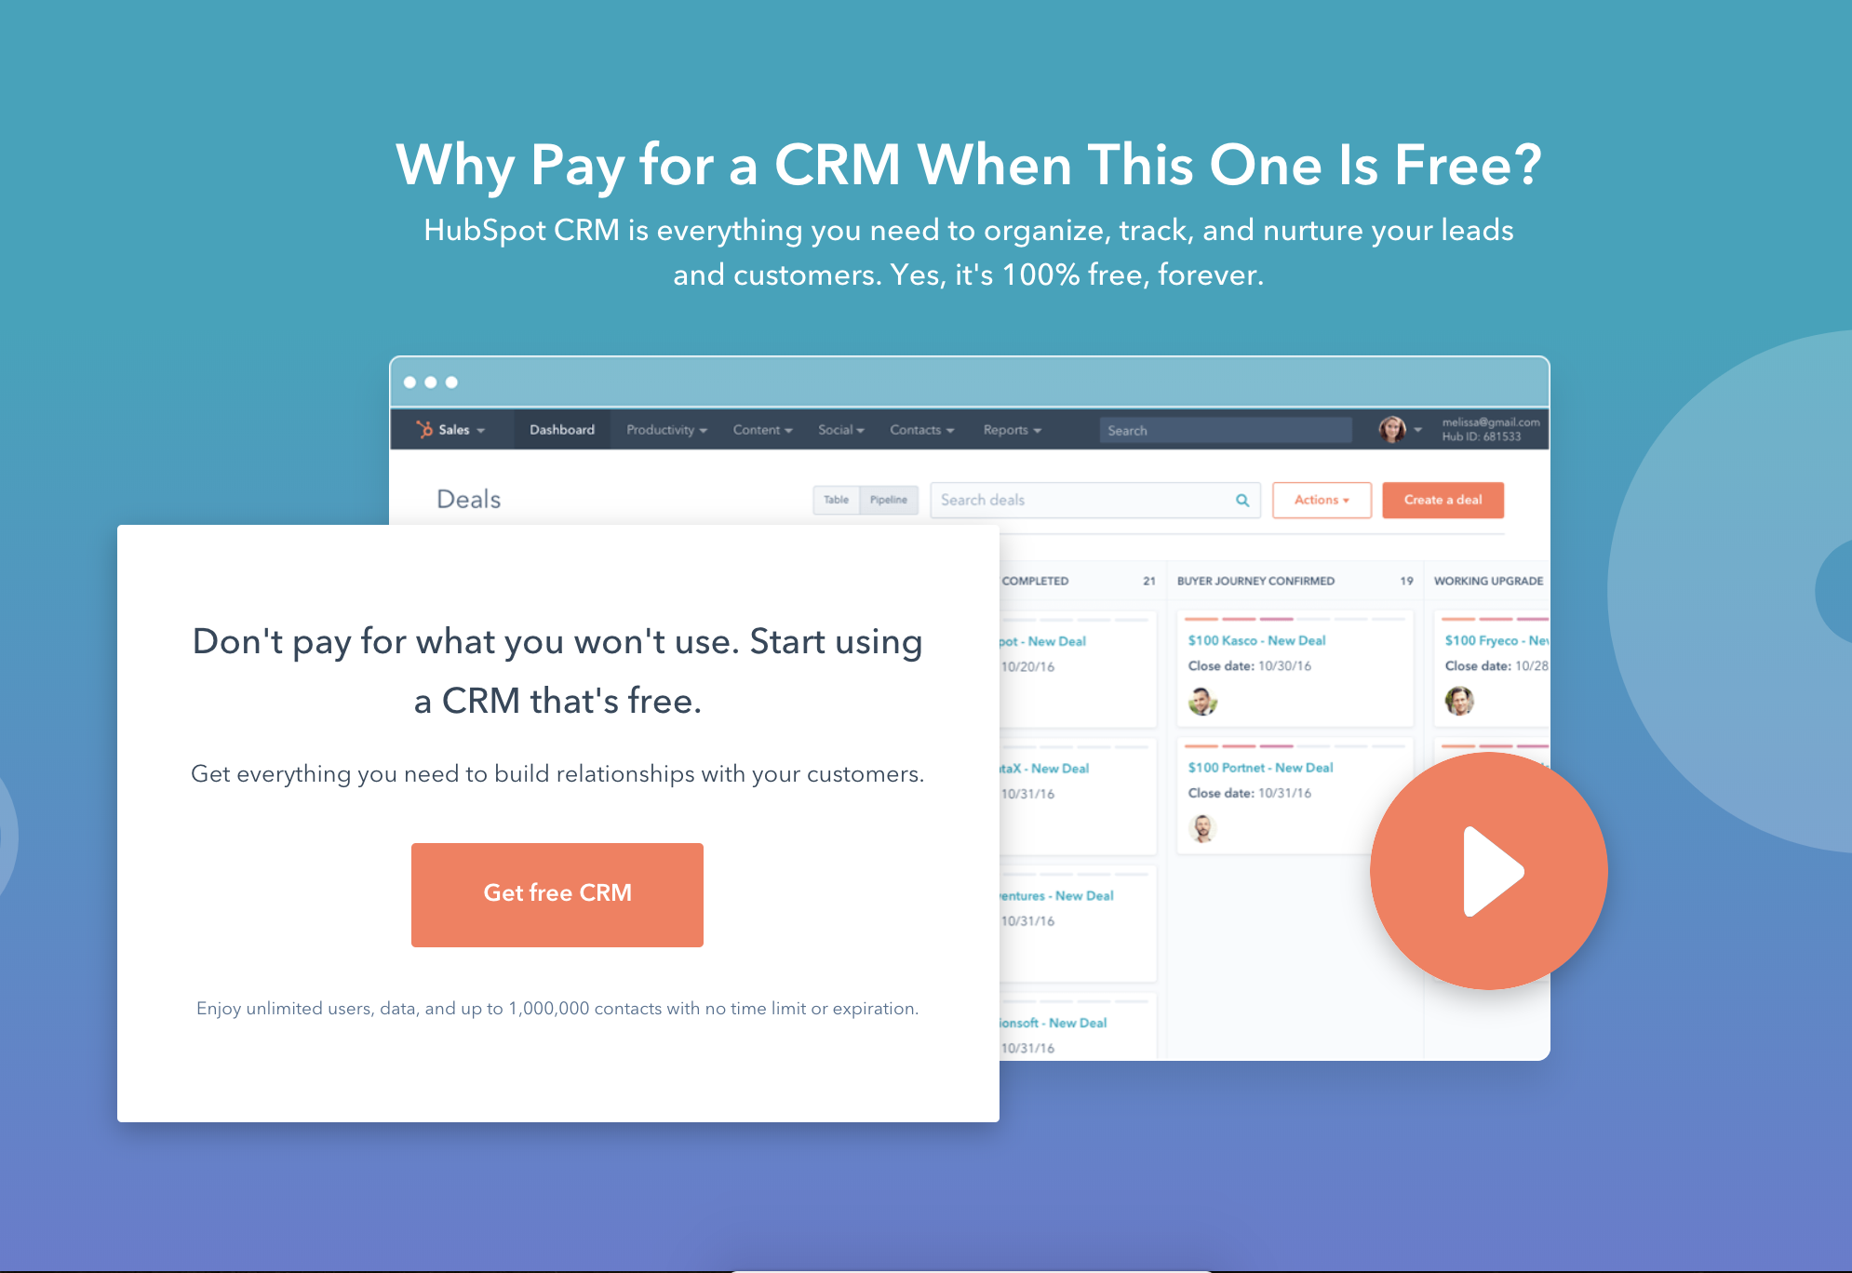
Get free CRM

(Keep scrolling to templates)
↓↓↓

Request for Proposal [SHORT]

RFP: [Project Name] | Proposal Due By: [Date] | [Company Name]
Project Overview:

[Insert Project Overview]
Project Goals:

- Goal 1
- Goal 2
- Goal 3
Scope of Work:

[Describe Scope of Work in Greater Detail]

Current Roadblocks and Barriers to Success

- Roadblock 1
- Roadblock 2
- Roadblock 3
Evaluation Metrics and Criteria

- Criteria #1
- Criteria #2
- Criteria #3
Submission Requirements

- Requirement #1
- Requirement #2
- Requirement #3
Project Due By: [Enter Project Due Date] |  | Budget: [Amount]
Contact: [Enter Name] | Email: [Enter Email] | Phone #: [Enter Number]

Request For Proposal
[LONG]

[PROJECT TITLE]
[YOUR COMPANY NAME]
PROPOSALS DUE BY: [DATE PROPOSALS WILL BE ACCEPTED UNTIL]
Company Background
This shouldn’t be a long history of your company. Rather, it should give contractors a better idea of what your company does and who you serve as a target market.
[EXPLAIN COMPANY IN 1-2 SENTENCES]

Project Overview
Before you go into the specifics of your company, you should give a brief introduction to the project itself so vendors know right away if it’s something worth bidding on.
[EXPLAIN PROJECT OVERVIEW IN 1-2 PARAGRAPHS]

Project Goals
Clearly identify what you hope to accomplish with this project and what you see as a “win” so everyone is on the same page.

The goals of this project include:
i. [INSERT COMPANY GOAL #1]
ii. [INSERT COMPANY GOAL #2]
iii. [INSERT COMPANY GOAL #3]

To reach these goals, [YOUR COMPANY] is now accepting bids in response to this Request for Proposal.

Scope of Work
The details of the project are essential in an RFP. In the same way you don’t want to use vague questions, a vague project scope won’t help you find the right vendor either. Spend time really detailing your project scope so there’s no surprises later on.
Include a description of the project and a detailed scope of work here. The description can be in paragraph form, a bulleted list, or a combination of both.

[EXPLAIN SCOPE OF PROJECT IN A FEW SENTENCES AND/OR BULLET POINTS.]

Target Deliverable Schedule
Do you have a target deliverable schedule in mind? This needs to be included in your RFP so potential vendors can properly gauge if they have the resources and bandwidth to complete the job on time.

Final Project Due: [PROJECT DUE DATE]
The expected project completion date is [ADD DATE]. If this date needs to be adjusted, please include your readjusted proposed date, as well as your reasoning for shifting the schedule. All proposed date changes will be considered.

Existing Roadblocks Or Technical Issues
Here, you’ll want to outline any time, resources, or other constraints that will affect both the proposal and the project.
A successful RFP is clear about any technical issues or possible roadblocks, such as: Are you dealing with custom coding or an outdated platform? Does your team have limited resources?
By explaining these up front, potential vendors will know exactly what they’re getting into. You’ll weed out contractors who can’t handle the task due to those constraints, but you’ll also connect with companies that know how to work around these common issues with skill and finesse.
Remember, it’s far better to find this out now than after you’ve accepted the bid and started work.

[OUTLINE YOUR ROADBLOCKS OR TECHNICAL CONSTRAINTS.]

Budget Constraints
It’s important to be upfront with your budget. The more you can eliminate surprises, the better for all parties involved.

[ENTER TARGET BUDGET AND/OR BUDGET CONSTRAINTS.]

Evaluation Metrics
How will you ultimately determine which contractor is the best fit for this project. List which criteria you will consider when choosing the company you will ultimately hire.

[YOUR COMPANY] will evaluate bidders and proposals based on the following criteria:
- Previous experience/past performance history.
- Samples and/or case studies from previous projects.
- Projected costs.
- Experience and technical expertise.
- Responsiveness and answers to questions in the next section.

Questions Bidders Must Answer To Be Considered
Create thought-provoking questions related to this project so you can properly assess potential vendors. You might want to know what issues a contractor sees up front or how the costs will break down.
Consider asking questions that you would in person or over the phone. List the questions bidders must answer in order to be chosen (or even considered).

i. [INSERT QUESTION #1]
ii. [INSERT QUESTION #2]
iii. [INSERT QUESTION #3]

Submission Requirements
Aside from required questions to answer and evaluation metrics, what will ultimately be necessary in order for the proposal to be considered?

Bidders must adhere to the following guidelines to be considered:
- Only bidders who meet all 5 metrics in the evaluation section should submit a proposal.
- Proposals must be sent in by [INSERT DATE]. Bidders who are interested in submitting a proposal should inform [POC NAME + EMAIL] no later than [INSERT DEADLINE].
- Include samples and references with your proposal.
- Proposals should not be more than [ENTER NUMBER] pages. Failure to comply to this guideline will result in an automatic rejection.
- A proposed schedule must also be included and clearly expressed.

What We’re Looking For in Potential Vendors
Another way to reduce or eliminate surprises on your RFP is to explain exactly what you’re looking for in potential contractors. You could also use this time to become a little more colloquial and explain what kind of communication or work ethic you expect from the contractor.

[ENTER YOUR EXPLANATION OF YOUR IDEAL VENDOR.]

Contact Information
Wrap things up with the best way to contact the RFP drafter and which email to submit the RFP to.

For questions or concerns connected to this RFP, we can be reached at:
[POC NAME]
[POC EMAIL]
[POC PHONE]

